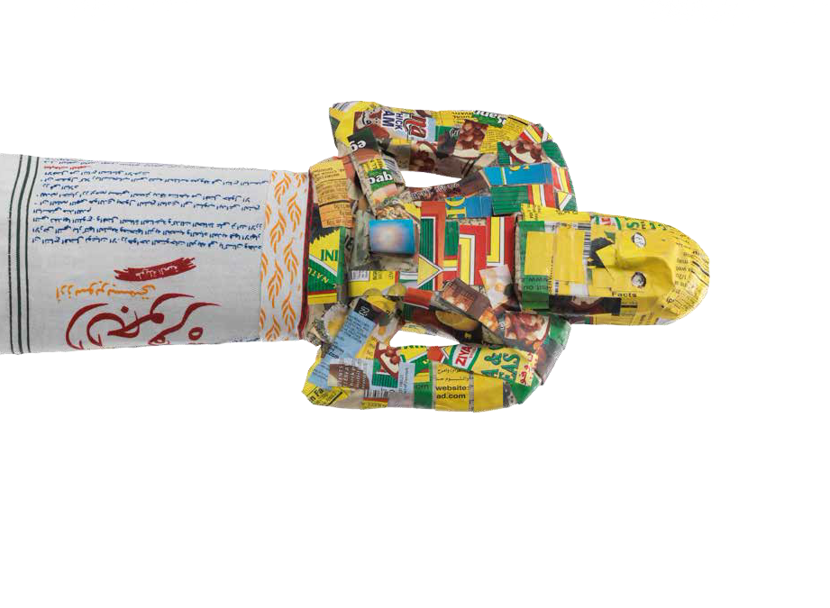

FROM ANCIENT TOMODERN
ARCHAEOLOGY ANDAESTHETICS

